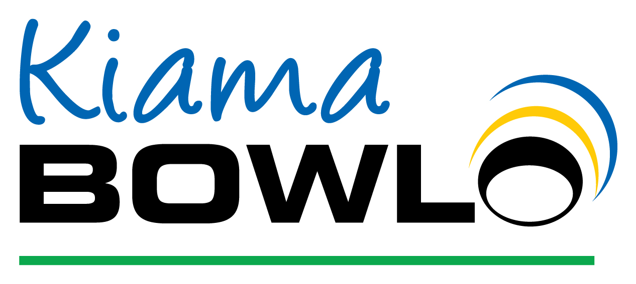
COVID-19 CONDITIONS OF ENTRY
WASH AND SANITISE HANDS AT OUR STATIONS AROUND THE CLUB AS
OFTEN AS POSSIBLE
KIAMA BOWLO CAPACITY LIMITS 50 PATRONS IN THE BAR/CAFÉ AREA AND 50 PATRONS IN THE SUMMIT BAR AND GRILL AREA
PLEASE REMAIN SEATED WHERE POSSIBLE WITHIN THE CLUB
STAY 1.5 METERS AWAY FROM ALL PATRONS
IF YOU SHOW ANY SIGNS OF SICKNESS PLEASE DO NOT ENTER
SIGN IN AT THE COVID-19 REGISTER
SANITISE YOURSELF ON ENTRY

